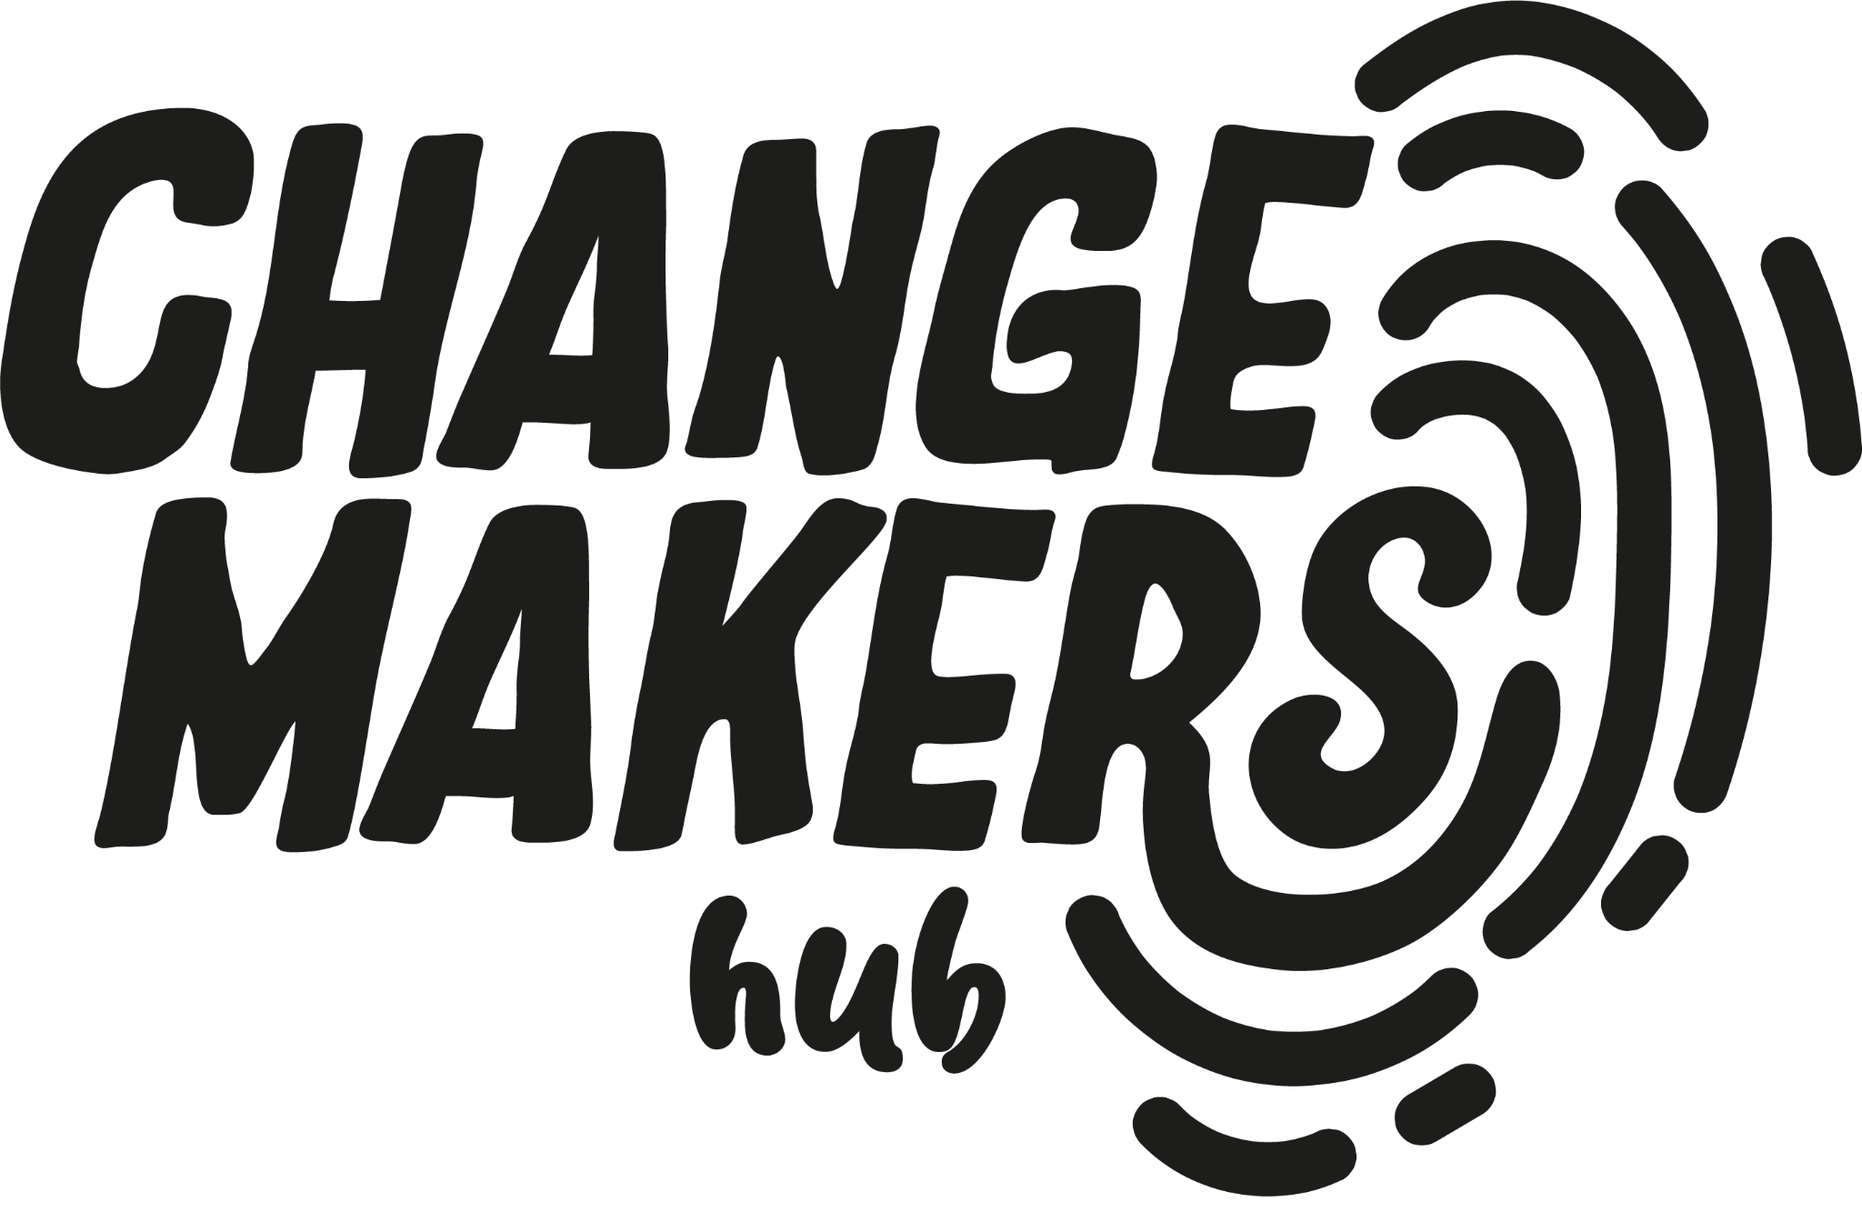
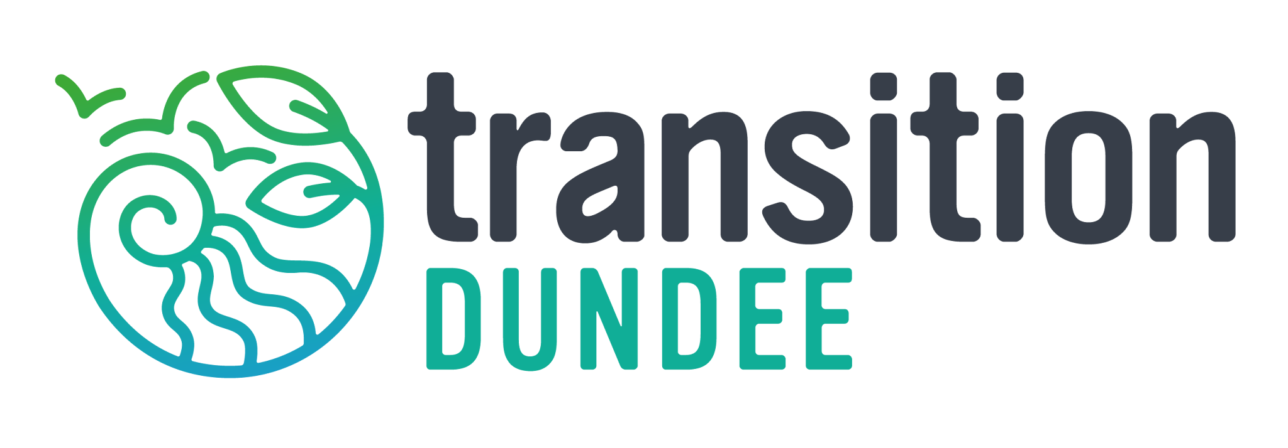

Dundee Changemakers Hub Manager

Responsible to: Programme Manager – Transition Dundee
Fixed term role: To 31 March 2027 (may be extended subject to funding)
Salary: £21,740 (£36,233 pro rata)
Hours of work: 3 days per week (7.5 hour day), flexible to suit applicant with some core team time requirements, may include occasional evenings/weekends
Holiday Entitlement: 18 days (30 pro rata, includes public holidays)
Pension: 8% Employer Contribution (+2% Employee contribution)
Location: Hybrid - 1-2 days in Dundee with 1 day hot desk provided in city centre

The Dundee Changemakers Hub, anchored by four community organisations and hosted by Transition Dundee, is a collective committed to fostering positive change and climate action in Dundee. Our partners - Transition Dundee, ScrapAntics, Uppertunity, The Maxwell - bring extensive experience in successful climate initiatives with a focus on engagement, diversity, and creativity. Together, we envision a sustainable and inclusive future for Dundee, connecting communities, sharing knowledge, and amplifying local voices. Join us in our mission to drive positive change and shape a shared vision for Dundee's communities and our environment.

The Hub is part of a national network funded by the Scottish Government’s Climate Action Fund. Climate Action Hubs aim to build local awareness of the climate emergency, develop local plans, help groups take up funding opportunities, and contribute to a Just Transition which is fair and leaves no one behind.

Summary

This role is responsible for the programme management of Dundee’s community climate action hub - Dundee Changemakers Hub. The post holder will manage all of the operational responsibilities for the hub, as well as ensuring that objectives are met in service of all stakeholders - Partners, Team, Community, Scottish Government and other local organisations.

The role is both managing the day-to-day running, and facilitating the future direction with stakeholders, developing strategies and frameworks to support the long-term sustainability of the hub.

Responsibilities:

Oversee Dundee Changemakers Partnership:
- Prepare for and host monthly meetings with core partners
- Develop and maintain documents such as partner agreements and meeting notes
- Liaise and communicate with partners on an ad hoc basis to progress activities and resolve issues

Oversee the day-to-day running of Changemakers Hub:
- Line manage hub team members including one-to-one support, team meetings, quarterly reviews and development days
- Maintain an overview of activity across people, projects and events
- Operational management of the programme, including HR related tasks, office/desk rental, team logistics and calendar management
- Support Communications and Events planning and delivery
- Ensure the Hub is adequately responding to enquiries via a centralised inbox

Strategy Development and Programme Management:
- Project manage the annual programme of work aligned with funder commitments
- Lead the development of the annual Scottish Government business case
- Coordinate resources across the programme, ensuring appropriate time and budget allocation to activities
- Support Partners with strategy development and implementation, facilitating sessions to reach consensus on governance, delivery and vision
- Manage quarterly and annual reporting for Scottish Government
- Attend monthly national hub meetings, learning and development sessions and annual gatherings, working with other Hubs as opportunities arise
- Gather lessons learned to inform the future of the programme
- Manage Changemakers budget and other financial aspects of programme with Transition Dundee, enabling financial reporting to Scottish Government
- Identify and coordinate opportunities for additional funding
- Oversee and support project development with team members, such as microgrants and membership development
- Act as an ambassador and representative for Dundee Changemakers, promoting the vision and ethos whenever possible
- Play a part in developing the sustainable future of the Dundee Changemakers programme and team

People Development
- Provide clear direction and support for Dundee Changemakers team members
- Support the development of individuals within the context of their role, helping to identify areas for development and growth
- Maintain regular, valuable team connection and working relationships
- Create a safe space for expression, inclusivity and diversity of backgrounds, experiences and thought

Experience and Skills

Essential:
- Proven experience in programme or project management and people management
- Experience of working within a funded environment
- Excellent organisational, communication, problem solving and interpersonal skills
- Passion for community building, networking, and social impact
- Digitally literate with experience of effectively using a range of digital tools and platforms, including Google workspace, Canva, Microsoft, etc.
- Experience of partnership working, preferably with local agencies and non-profit organisations
Desirable
- Keen interest in climate, environmental and social issues affecting communities
- Evidence of staying connected to national and local developments in issues around climate change and social action
- Understanding of Dundee community and third sector network with existing connections
- Experience of working in a charitable organisation/social enterprise
- Experience both writing and staying up to date with operational policies and procedures

Employment Terms:

Contract: Fixed term ending 31st March 2027 (with the ambition to extend the role subject to funding). This role is employed by Transition Dundee. All post holders are subject to a probationary period of three months. Employer pension contribution (8% employer contribution, 2% employee), and annual training and wellbeing allowance provided.

Hours: 3 days/22.5 hours per week, with 1-2 days likely in Dundee.

Equal opportunities: Transition Dundee is committed to being an equal opportunities organisation and welcomes all applications for consideration.

We know there are candidates who may not fit every criteria we’ve outlined here, or who have key skills we haven’t listed. If this is you, please do apply if you feel your particular experience or skillset could enhance this role and state clearly in your application how you would do that.

We want to ensure that our application process does not present any accessibility barriers to potential applicants. Please let us know if you have any requirements that would reduce barriers to applying for this role.

Application Process:
Please submit your application in one single document, either Word or PDF, with a maximum of 3 pages (cover letter 1 page and CV 2 pages combined) and name the file YOURNAME_HUBMANAGER to shona@dundee-changemakers.net
Please read the Person Specification carefully and explain in your CV/Cover Letter which of the ‘Essential’ or ‘Desirable’ requirements you meet, any relevant experience and why you would like to work as part of Dundee Changemakers (Transition Dundee).
The deadline for applications is midnight on 12 July 2026.
Interviews will be conducted in person. We will consider requests for virtual if appropriate, please state in your cover letter if this is a requirement and why.
